1(e)

Accuracy: 0.17777777777777778

1(f)

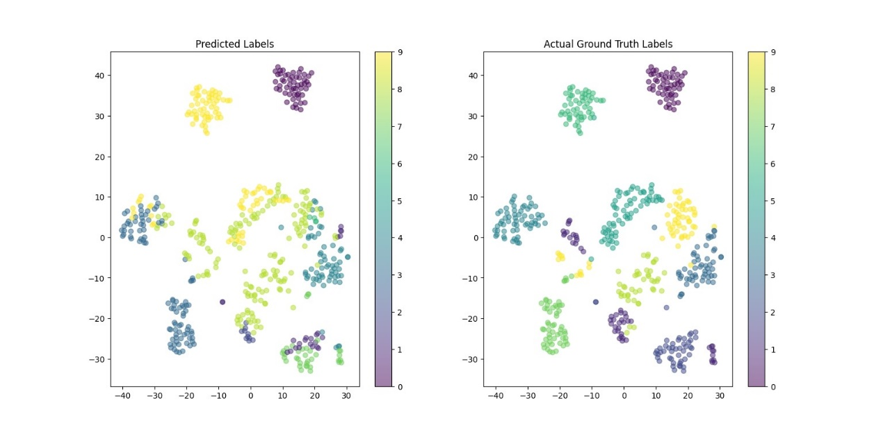

2(e)

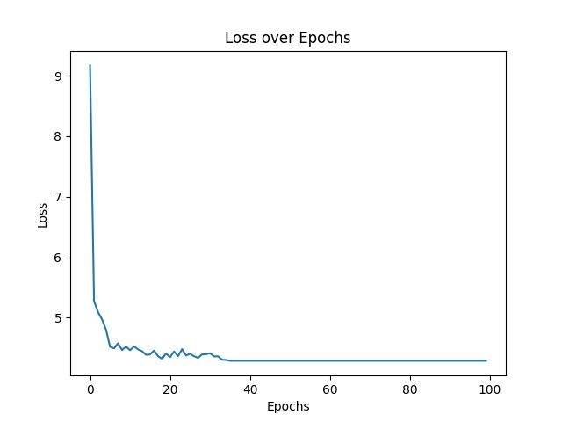

2(f)

Average cross entropy loss: 4.03189732625256